**Screenshots for Our Website Pages Using Figma:**

**2,3-Register & Search and display available courses (Use case 2,3):**

**1. PC View:**

1. **Default Page:**

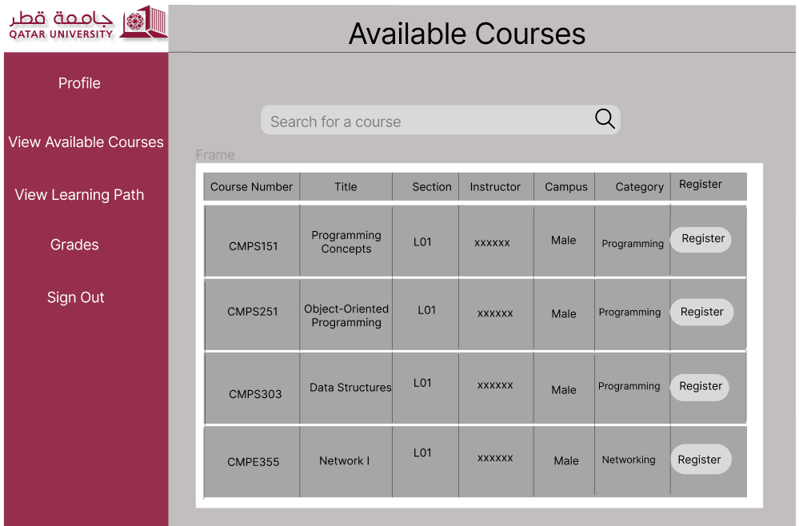

1. **When Searching:**

**2. Mobile View:**

1. **Default Page:**

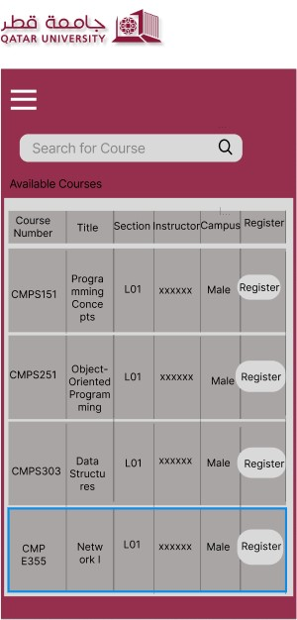

1. **When searching:**

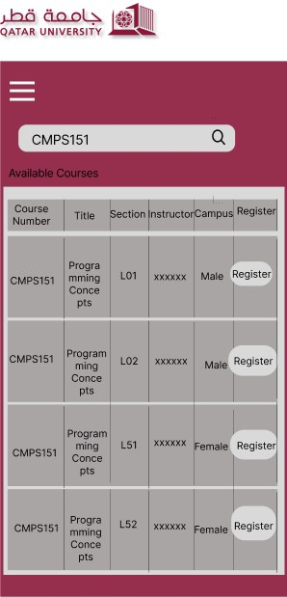

**6- Grades Submission (Use case 6):**

1. **PC View:**

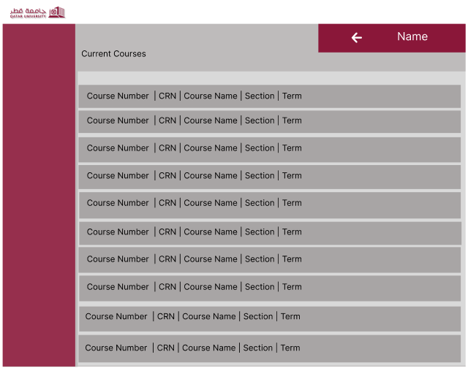

1. **Mobile View:**

